Current Operable Unit 3 Remedial Progress for Week Ending 1/29/10
Creamer Environmental Inc., National Grid’s Remediation Contractor, is finishing the excavation and backfill where the LIRR tracks were relocated. To date, 188 trucks have transported approximately 4627.73 tons (3085.15cubic yards) of soil to Bay Shore Soil Management (formerly ESMI of NJ) for thermal desorption. Additionally 115,763 gallons of impacted excavation water has been disposed of at Clean Waters of Staten Island and Bridgeport United Recycling in Connecticut. Excavation and load out of Cell 6 and 7 were completed this week.
GEI, National Grid’s Remediation Oversight Consultant, continues to perform Community Air Monitoring Program (CAMP), noise, and vibration monitoring. CAMP, noise, and vibration monitoring will continue throughout the project.

Two-Week Outlook
Creamer Environmental will start the restoration phase of Phase I, which will include the reconstruction of the sub-grade for the original LIRR track alignment and the removal of temporary facilities and controls. Phase 1 restoration is anticipated to continue until mid to late February. Following the restoration portion of Phase I, the LIRR will start restoration of the signal and communication lines back to their original locations, as well as other miscellaneous tasks, in preparation for relocating the tracks to back to the original alignment.
General hours of operation will continue to be Monday through Friday, 7:00 AM to 3:30 PM. However, work hours will be extended when necessary to maintain schedule or to complete critical tasks.
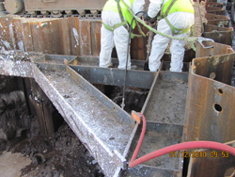
Hand removal of impacted material from corners of the sheet piling
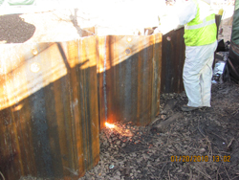
Removal of sheet piling to design elevation

